

**®**

**RADIO FREE ASIA RELEASES YEAR OF THE RAT QSL**

**JANUARY 2020**

Radio Free Asia (RFA) announces its Chinese Lunar Year QSL. The Year of the Rat begins January 25, 2020 and ends February 11, 2021. The rat is one of twelve animals used in the Chinese zodiac. Those born in a rat year are considered ambitious, meticulous, industrious and sociable. They are also are very focused, naturals at following their instincts, and they are highly attentive which supposedly makes them excellent in business. This is RFA’s 72nd QSL and is used to confirm all valid RFA reception reports January – April 2020.

**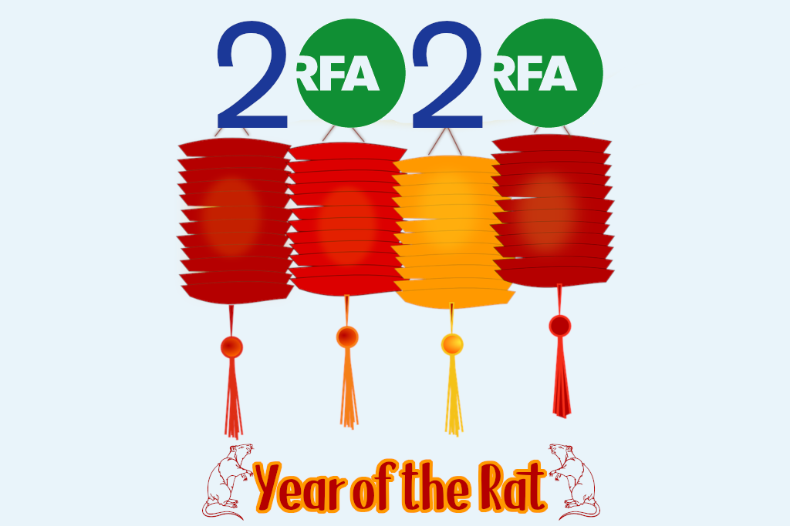*RFA’s Year of the Rat QSL***

Created by Congress in 1994 and incorporated in 1996, RFA broadcasts in Burmese, Cantonese, Khmer, Korean to North Korea, Lao, Mandarin Chinese, Vietnamese, Tibetan (including Uke, Amdo, and Kham dialects), and Uyghur. RFA strives for accuracy, balance, and fairness in our editorial content. As a ‘surrogate’ broadcaster, RFA provides news and commentary specific to each of our target countries, acting as the free press these countries lack. RFA broadcasts only in local languages and dialects, and most of our broadcasts comprise news of specific local interest. More information about RFA, including our current broadcast frequency schedule, is always available at www.rfa.org.

RFA encourages listeners to submit reception reports. Reception reports are valuable to RFA as they help us evaluate the signal strength and quality of our transmissions. RFA confirms all accurate reception reports by mailing a QSL card to the listener. RFA welcomes all reception report submissions at http://techweb.rfa.org (follow the QSL REPORTS link) not only from DXers, but also from our general listening audience.

Reception reports are also accepted by email at qsl@rfa.org and by mail to:

Reception Reports

Radio Free Asia

2025 M. Street NW, Suite 300

Washington DC 20036

United States of America

# # #